Anthony Redamonti

Syracuse university

Week 1 Essay Question

CSE-682 Software Engineering

prof. Hesham Saadawi

1/10/2023

Question

Suggest the most appropriate software process model that might be used as a basis for managing the development of the following systems. Give your reasons.

1. A system to control anti-lock braking in a car.
2. A university accounting system that replaces an existing system.
3. An interactive travel-planning system that helps users plan trips with the lowest environmental impact.
4. The most appropriate software process model that might be used as a basis for managing the development of a system to control anti-lock braking in a car would be the waterfall model.

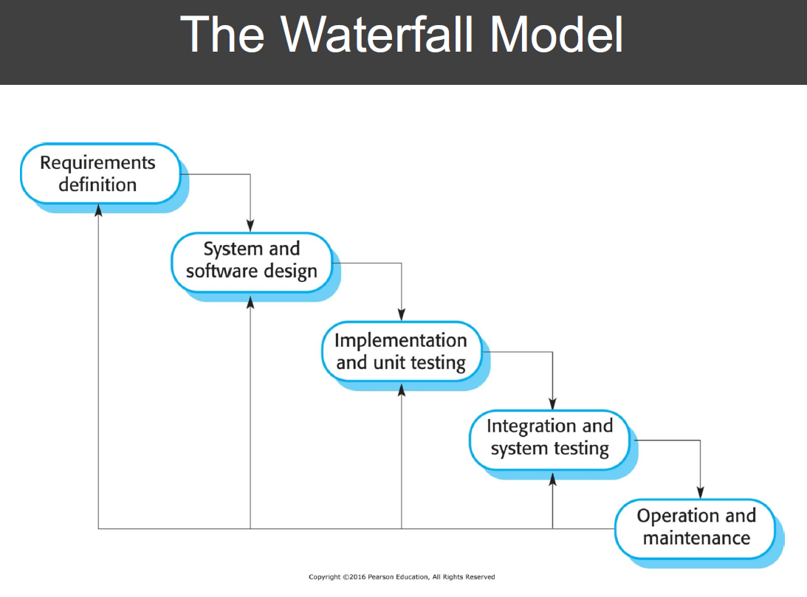

The waterfall model is ideal for systems that are plan-driven such that each stage is carried out sequentially. Systems that adopt this process model have well established specifications and requirements. Changes to the design process are fairly limited. The anti-lock braking system in automobiles is a crucial safety system that has many requirements set by standards defined by organizations and technical committees. Changes to these requirements do not happen with great frequency.

1. The most appropriate software process model that might be used as a basis for managing the development of a university accounting system that replaces an existing system would be the reuse-oriented software engineering model.

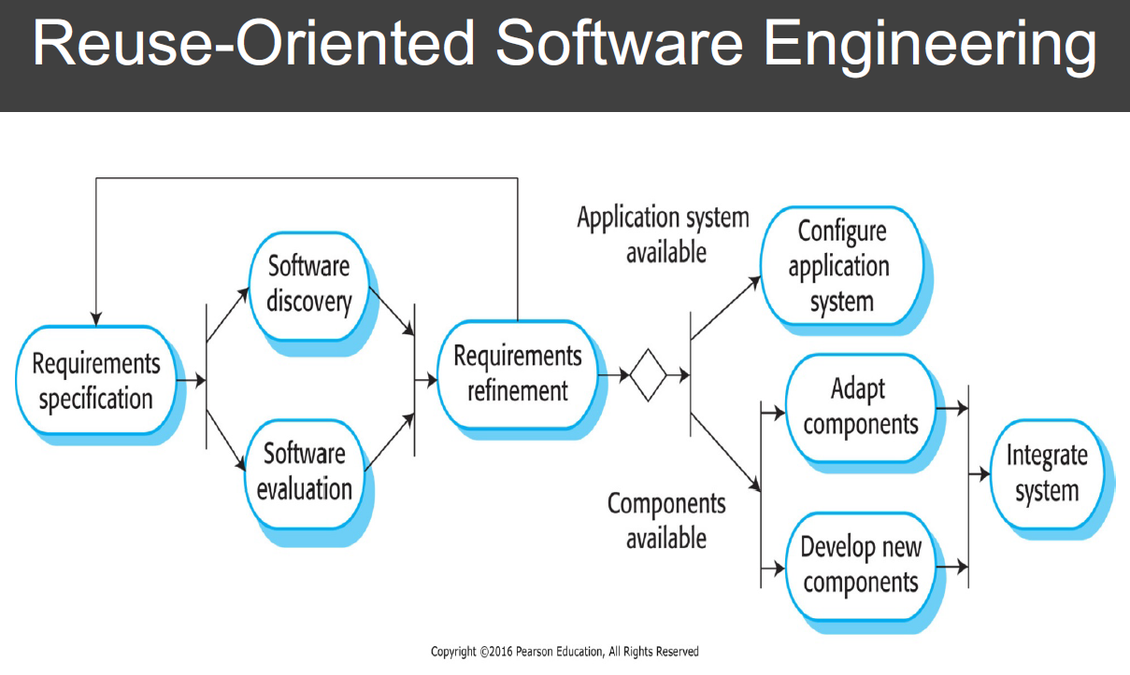

The reuse-oriented software engineering model is intended to be used by systems that are assembled from existing components. Elements from the old university accounting system, such as calculating student loan amounts or interacting with other banking services, can be utilized in the new system. Reusing functional elements from an existing system is a common approach for building many types of systems as it avoids developing new software needlessly. It saves time and effort and is safe to implement, as the components in the existing software have already gone through testing and been used in existing systems.

1. The most appropriate software process model that might be used as a basis for managing the development of an interactive travel-planning system that helps users plan trips with the lowest environmental impact would be the incremental development model.

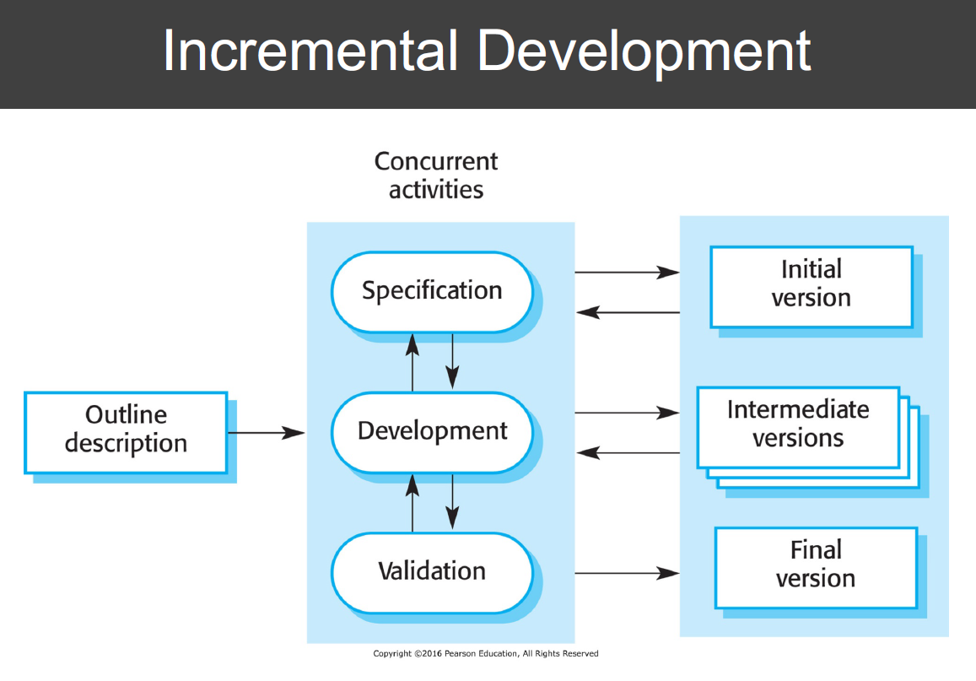

In the incremental development model, specification, development, and validation are interleaved. Because it is a system that interacts with customers, probably through a graphical user interface, it is necessary to receive customer feedback during the demonstration of the software. Using this model also reduces the cost of documentation, as there are many changes made throughout the interleaved specification, development, and validation processes. It also yields a more rapid delivery and deployment of the software to the customer than the waterfall model.